Task 2

Data Engineering

Done my Mohammed Aljehani

Phase 1 :

Task 1 :

ERD Star Schema for FactInternetSales :

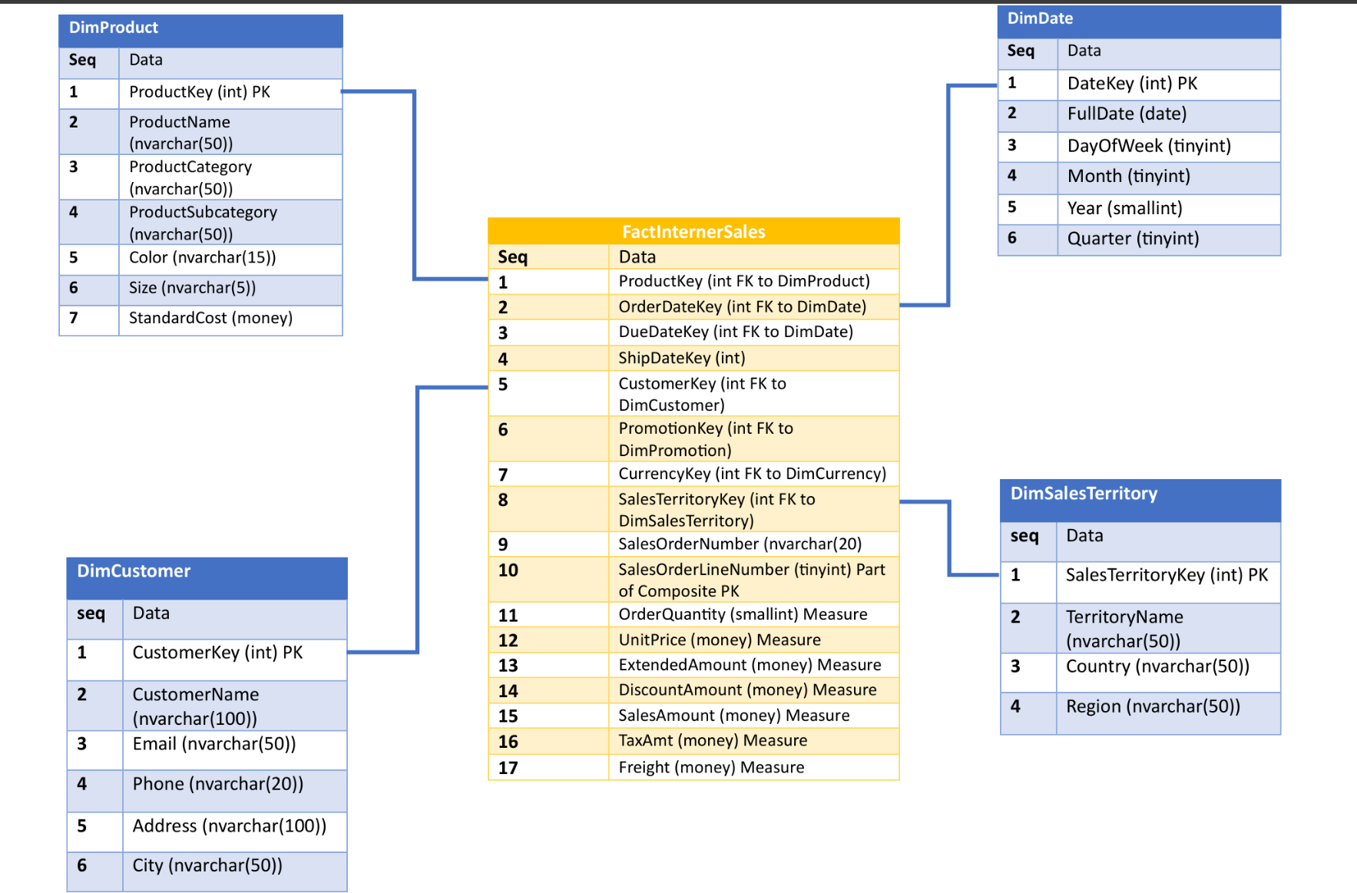

Task 2 : Sales Performance Analysis

Work:

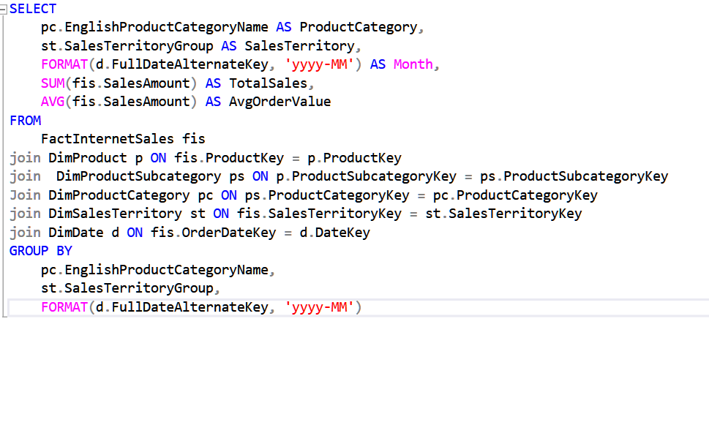

Results :

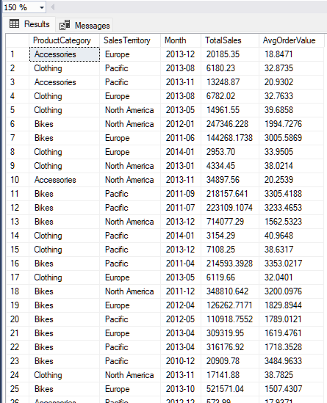

Task 3 : Inventory & Margin Report

Work :

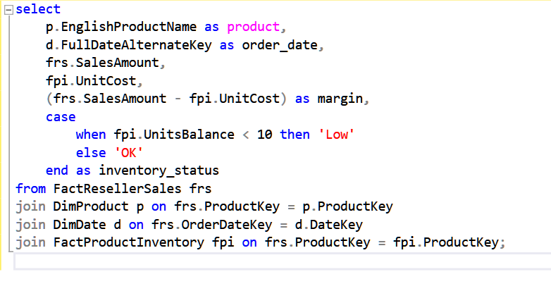

Result :

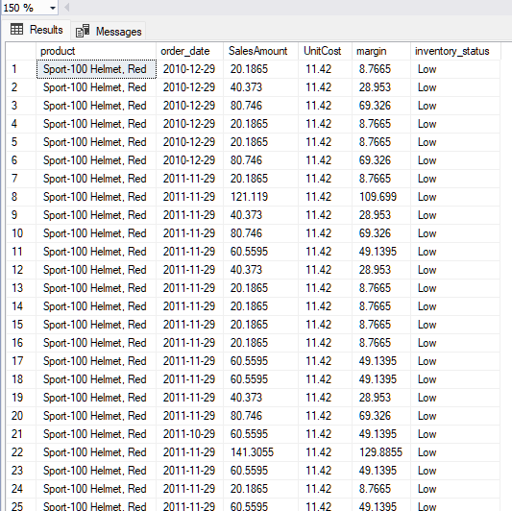

Task 4 : Order Lifecycle & Delivery Delay

Work :

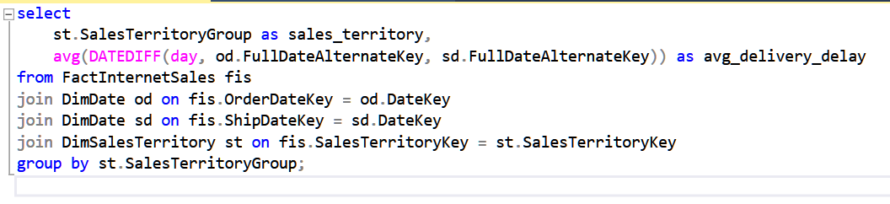

Results :

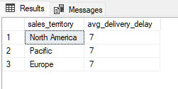

Task 5 : Sales Reason Attribution (Bridge Table: M:M)

Work :

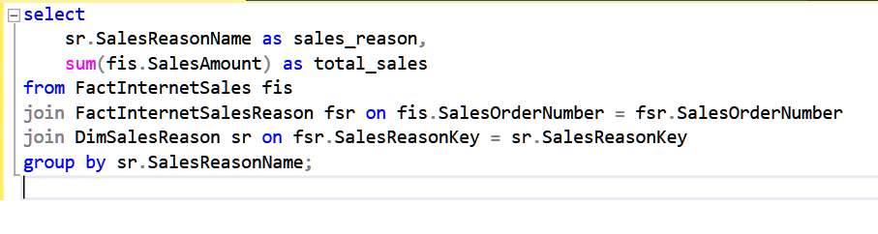

Results :

